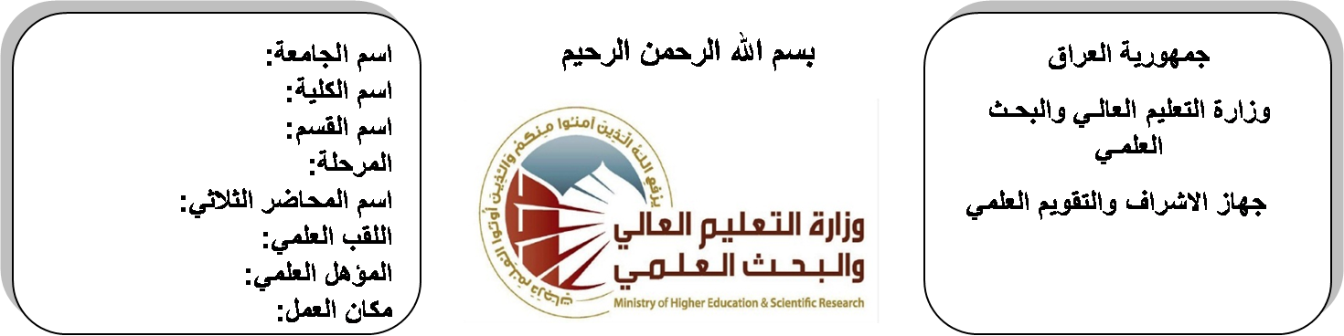

**Republic of Iraq**

**Ministry of Higher Education**

**& Scientific Research**

**University: Diyala University**

**College: College of Engineering**

**Department: Electronic Engineering**

**Stage: second stage**

**Lecturer name: Ayad Qays**

**Qualification: Msc**

**Place of work: Electronic Dept.**

**(( Annual teaching plan form))**

|  |  |  |  |  |
| --- | --- | --- | --- | --- |
| **Lecturer Name** | **Ayad Qays Abdulkareem** | | | |
| **Email** | **Aiyad_qais@yahoo.com** | | | |
| **Subject** | Mathematics II | | | |
| **Aims** | **The aim of this subject is to make the students ready to undestand and comprehend the scientific theories and their applications related to their field of the study.** | | | |
| **Textbooks** | Calculus by Thomas | | | |
| **Additional Textbooks** | Calculus by James Stewart ,Barbara Frank. | | | |
| **Assessments** | **First Semester** | **Second Semester** | **Laboratory** | **Final Exam** |
| 20 % | 20 % |  | 60 % |
| **Notes** |  | | | |

**Schedule Weekly Lessons - First Semester**

|  |  |  |  |  |
| --- | --- | --- | --- | --- |
| **Week** | **Date** | **Lectures** | **Lab. Experments** | **Notes** |
| 1 | **29/9/** | **Sequences and series** |  |  |
| 2 | **5/10/** | **Sequences and series** |  |  |
| 3 | **12/10** | **Sequences and series** |  |  |
| 4 | **19/10** | **Partial Differentiation** |  |  |
| 5 | **26/10** | **Partial Differentiation** |  |  |
| 6 | **2/11** | **Partial Differentiation** |  |  |
| 7 | **9/11** | **Ordinary Differential Equations** |  |  |
| 8 | **16/11** | **Ordinary Differential Equations** |  |  |
| 9 | **23/11** | **Ordinary Differential Equations** |  |  |
| 10 | **30/11** | **Laplace Transform(L.T)** |  |  |
| 11 | **7/12** | **Laplace Transform(L.T)** |  |  |
| 12 | **14/12** | **Laplace Transform(L.T)** |  |  |
| 13 | **21/12** | **Fourier Series** |  |  |
| 14 | **28/12** | **Fourier Series** |  |  |
| 15 | **4/1** | **Fourier Series** |  |  |
| 16 | **11/1** | **Multiple Integrals** |  |  |
| Half Year holiday | 15/1/ to  1/2/ |  |  |  |

**Lecturer Signature Head of Dept. Signature Dean Signature**

**Schedule Weekly Lessons - Second Semester**

|  |  |  |  |  |
| --- | --- | --- | --- | --- |
| **Week** | **Date** | **Lectures** | **Lab. Experments** | **Notes** |
| 1 | **15/2** | **Multiple Integrals** |  |  |
| 2 | **22/2** | **Multiple Integrals** |  |  |
| 3 | **1/3** | **Vector analysis** |  |  |
| 4 | **8/3** | **Vector analysis** |  |  |
| 5 | **15/3** | **Vector analysis** |  |  |
| 6 | **22/3** | **Vector analysis** |  |  |
| 7 | **29/3** | **Vector analysis** |  |  |
| 8 | **5/4** | **Matrices** |  |  |
| 9 | **12/4** | **Matrices** |  |  |
| 10 | **19/4** | **Matrices** |  |  |
| 11 | **26/4** | **Matrices** |  |  |
| 12 | **3/5** | **Matrices** |  |  |
| 13 | **10/5** | **Matrices** |  |  |
| 14 | **17/5** | **Matrices** |  |  |
| 15 | **24/5** | **Matrices** |  |  |
| 16 | **1/6** | **Matrices** |  |  |

**Lecturer Signature Head of Dept. Signature Dean Signature**